Bampton and District Local History Society members’ meetings
Economic Migration in the 1800s: starting a new life in Manchester for Westmorland Families
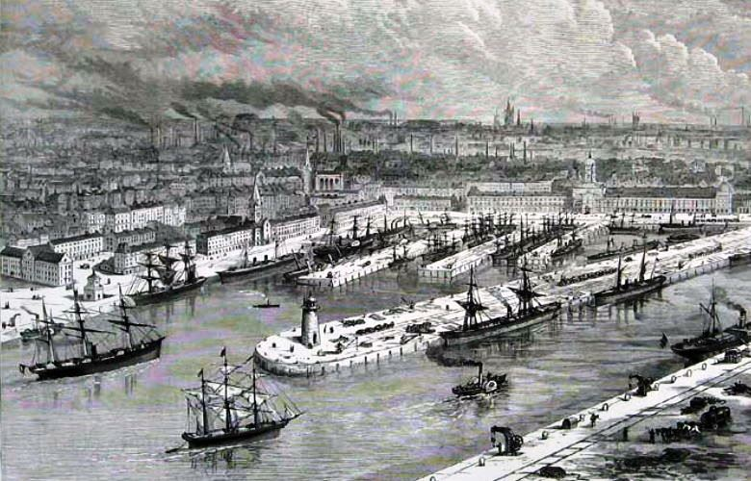
Val Fermer

Tuesday 4th March 2025
7:30pm
Bampton Memorial Hall
Everyone welcome!
Home-baked refreshments will be served
Members £1 Visitors £3

